Colegio Modelo Marmol

6ºA/B

Today is Thursday, 25th June 2020

Numbers

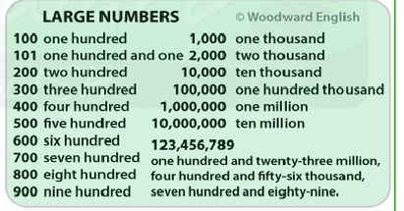

* Instead of saying **One Hundred**, you can say **A hundred.**

e.g. (127) **one hundred and twenty-seven** OR (127) a hundred and twenty-seven.

The same rule applies for **one thousand (a thousand) and one million (a million**)

**Let’s work!**

Solve the following interactive activity

<https://es.liveworksheets.com/ch802232eo>

(Resolvemos la actividad online , hacemos click en TERMINADO, completamos con nuestros datos y la envían para la corrección a mi mail [slvncpr@gmail.com](mailto:slvncpr@gmail.com) .)

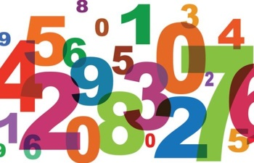Numbers

Choose the correct option

|  |  |
| --- | --- |
| Four thousand, five hundred and sixty-eight | 468 458 4,568 |
| Eight hundred and four | 804 84 8004 |
| eight thousand and sixty-five | 865 805 8,065 |
| one thousand | 100 1001 1,000 |
| Five thousand and eighty-four | 584 5084 5804 |
| two thousand, five hundred and sixty-four | 256 2064 2,564 |
| Four hundred and sixty-two | 462 4062 4602 |
| one thousand, one hundred and eleven | 1,111 111 1011 |
| three thousand, seven hundred and forty-seven | 374 3,747 3477 |
| Two hundred fifty-six | 256 2560 2056 |
| five thousand, nine hundred and two | 592 5,902 5920 |
| six thousand, six hundred and ninety | 6,690 669 6069 |
| Two thousand eight hundred and sixty | 286 2086 2860 |
| Three hundred and three | 303 3003 3030 |
| two thousand and three | 203 2,003 2030 |
| seven thousand, five hundred and one | 751 7,501 7510 |
| nine thousand, eight hundred and thirty-seven | 983 9937 9,837 |
| four thousand, four hundred and sixty-four | 446 4064 4,464 |

