Thursday, 13th August

**Book (Page 24)**

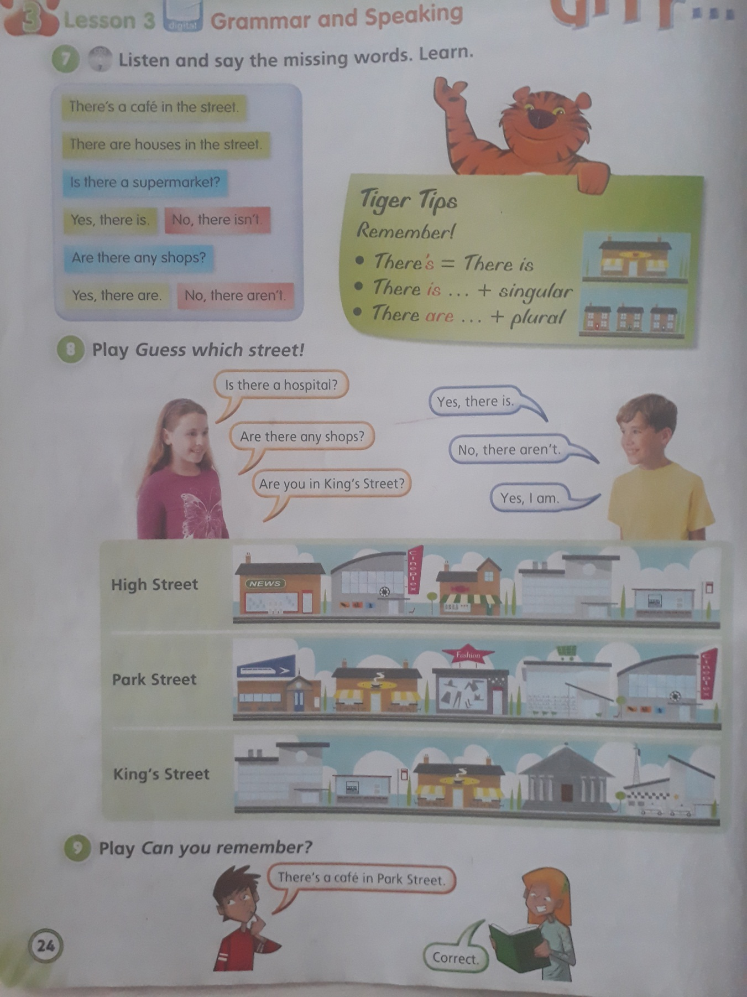

Look at the pictures in activity 8. Answer: Yes, there is. / No, there isn’t.

Yes, there are. / No, there aren’t.

1. Is there a café in High Street?
2. Are there any houses in Park Street?
3. Is there a museum in King’s Street?
4. Are there any shops in High Street?
5. Is there a supermarket in Park Street?

**Write:** Yes or No

1. There’s a café in High Street. NO
2. There are houses in King’s Street.
3. There’s a train station in Park Street.
4. There’s a hospital in Park Street.
5. There are shops in High Street.