Tuesday, 3rd November

*Things we like doing*

***Vocabulary***

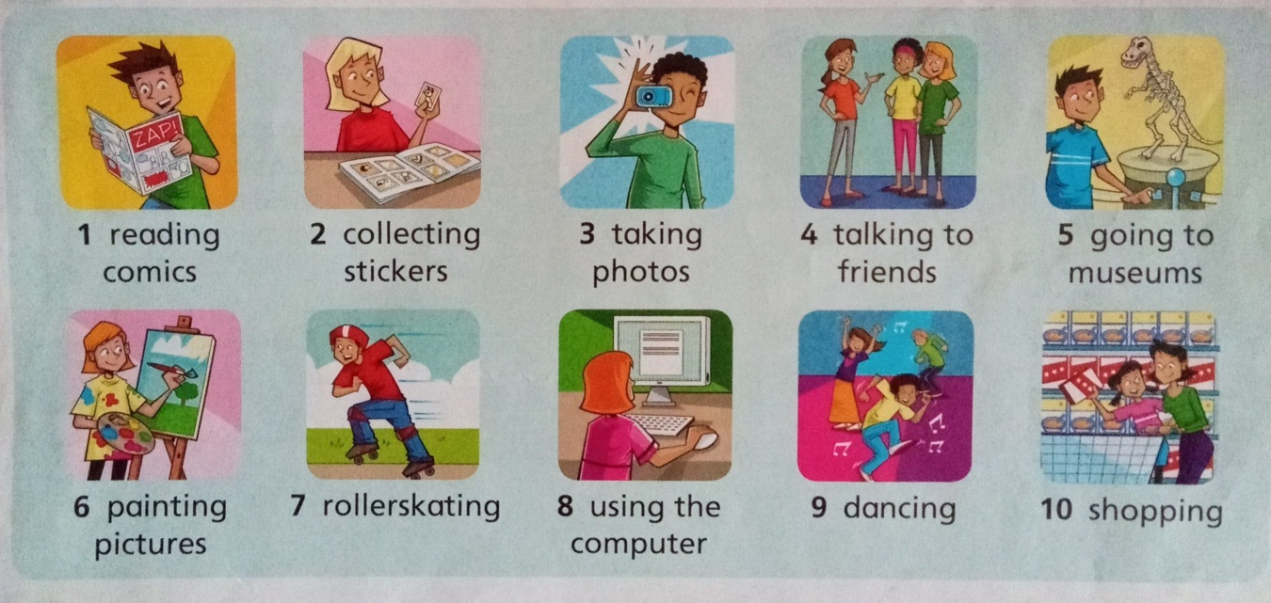

Answer (responder)

What is your favourite activity?

It is …

**Booklet (Page 37)**

**Activity 1**

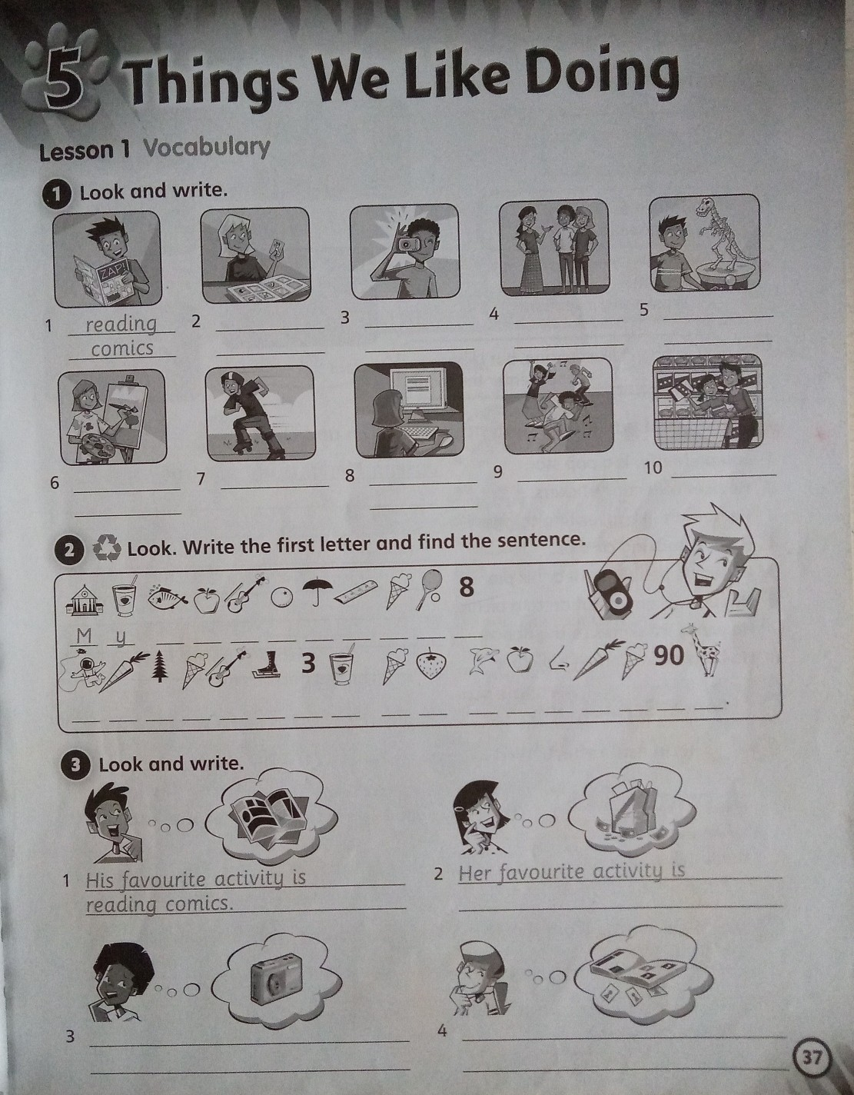

1. Reading comics

**Activity 2**



Recuerden que en esta actividad deben usar la letra inicial del nombre de cada dibujo. Se formará una oración.

Museum = **M** yogurt = **Y**

**My …**

**Activity 3**



1. His favourite activity is reading comics.
2. Her favourite activity is …
3. His …
4. Her …